Pre-op skin protection before surgical procedures
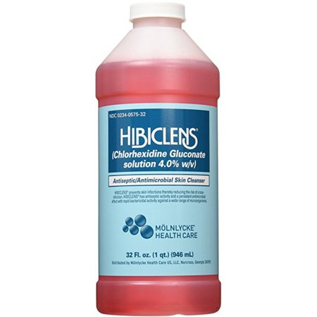
Getting ready for surgery
- If you plan to wash your hair, use your regular shampoo; then rinse your hair and body thoroughly to remove any shampoo residue
- Wash your face with your regular soap or water only
- Completely rinse your body with water from the neck down
- Put it directly on your skin or on a wet washcloth and wash gently
  - Move away from the water when using it - to avoid rinsing it off too soon
- Rinse with warm water and keep out of eyes, ears and mouth
  - If it gets in eyes, ears or mouth, rinse out right away
- Dry your skin with a towel
- Do not use your regular soap after applying and rinsing with Hibiclens®
- Do not apply lotions or deodorants to the cleaned body area
General Information when using Hibiclens®:
- If it gets onto cloth, do not bleach it!
  - Using bleach may leave a brown stain
- Can be found at Target, Walmart, Walgreens, CVS, Rite-Aid, etc.
  - ~$9-12
- Is available over the counter - a prescription is not required for use.
Be sure to follow your doctor’s orders!

